**Deployment Document Mail merge automation**

1] check macro Icon exist in your word file in menu section

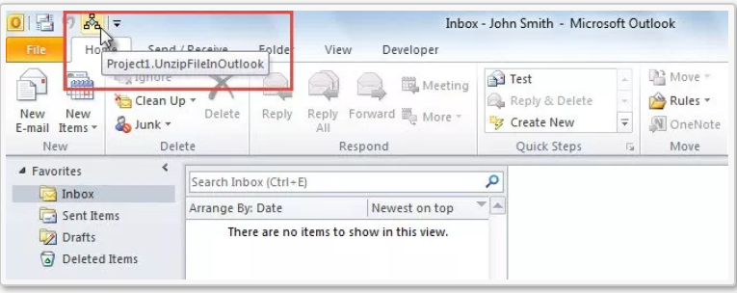

2] if it is exists then click on that icon for run Macro and follow below steps

**After Run Macro do below things:**

1] you will get select Input Excel Files message box click on OK

2] after that you will get file selection option as select Input Excel Files

3] then select input excel file

4] then you will get message “LastRow of Excel : *” click on OK

5] then you will get message Select Folder For Save PDF Files click on ok

7] after that folder path selection option comes then select folder to save pdf file

8] after that you will get popup to save udated excel file with link

9] give any name and save it

10] finally you will get message “Word Records Converted To PDF successfully”

11] click on OK

12] after that you can compare word data with PDF Data

13] finally close macro template without saving It.

3] else do below steps

**Add Macro In Outlook**

**Step 1: Enable Developer Tab**

1] First of all, after launching Outlook, access “File” menu.

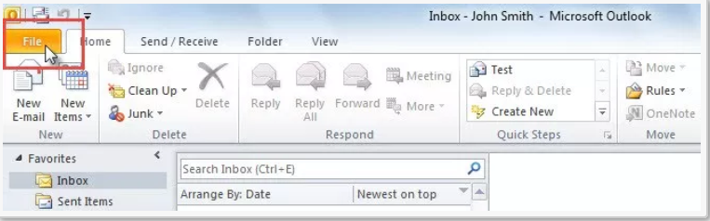

2] Then in “File” menu select and click on “Options”.

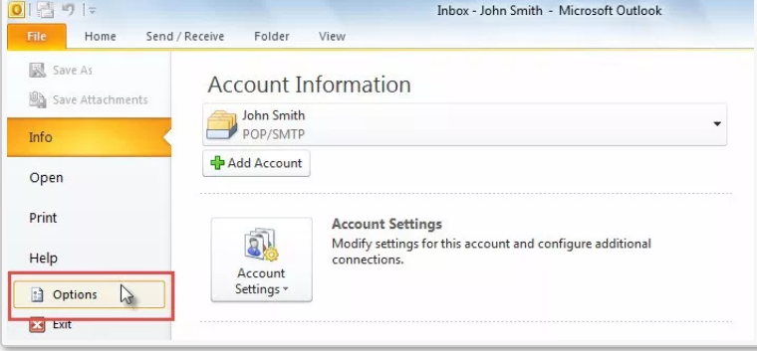

3] Next, in the popup “Outlook Options” window, switch to “Customize Ribbon”.

4] Later, on the right side, you can find out and enable the “Developer” tab.

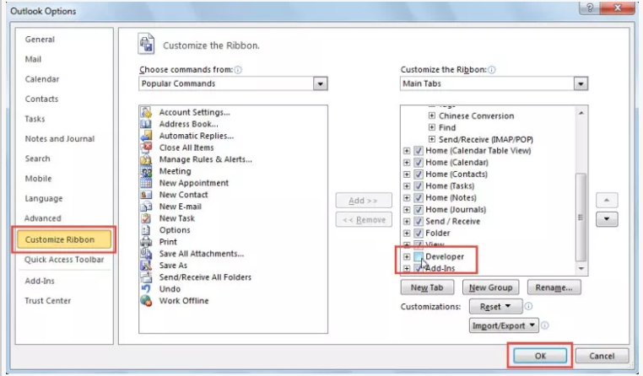

**Step 2: Check Macro Security Settings**

1] After returning to Outlook main window, you can access “Developer” ribbon.

2] Then, click on the “Macro Security” button.

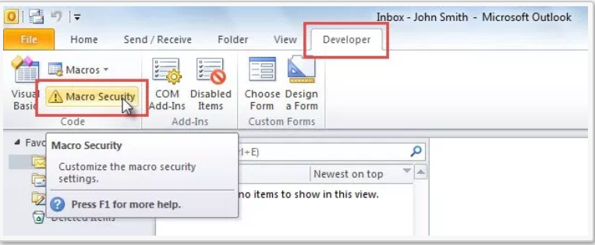

3] In the subsequent screen, you should select “Notifications for all macros” and hit “OK” button.

Or You can select Enable all macros

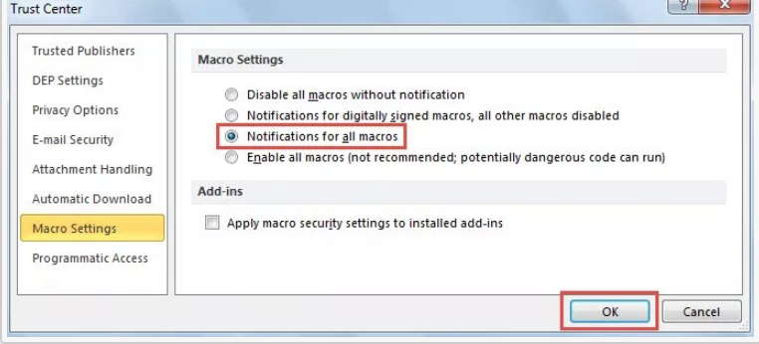

**Step 3: Access Outlook VBA Editor**

To run VBA code, you have to access the VBA editor firstly, which can be achieved by the following 2 means:

1] In Outlook, under the “Developer” tab, click on the “Visual Basic” button.

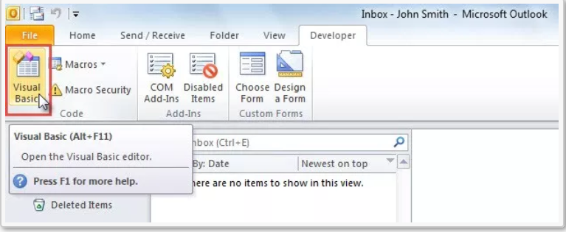

2] Or you can directly press “Alt + F11” key buttons.

**Step 4: Add VBA Code**

1] you can copy the VBA code into a module.

2] Click “Insert” button in the menu bar.

3] Choose “Module” from the drop down list.

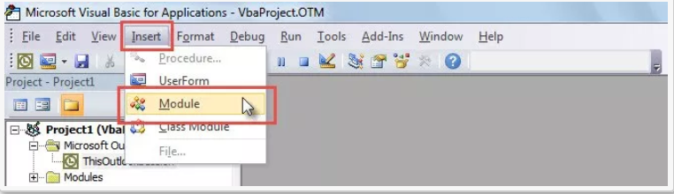

4] Then, a new module will display. Now you can copy code into the module as usual.

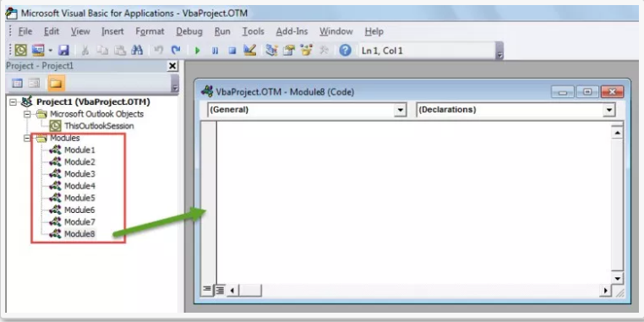

3] open notepad file “macro_script”

4] copy code from notepad and paste it into module

**Step 5: Run VBA Code**

**Add Macro to Quick Access Toolbar or Ribbon**

If you would like to run macro in the main Outlook window instead of in the VBA editor, you can add the macro to Quick Access Toolbar or ribbon.

**Add Macro to Quick Access Toolbar**

1] First off, access “Outlook Options” by following the operations shown in Step 1, in which you can shift to “Quick Access Toolbar” tab.

2] Next, select “Macros” from the “Choose commands from”.

3] Then, in the macro list, choose a macro

4] select macro Project1. WordToPdfSaveTwo

5] After that, click “Add >>” button in center.

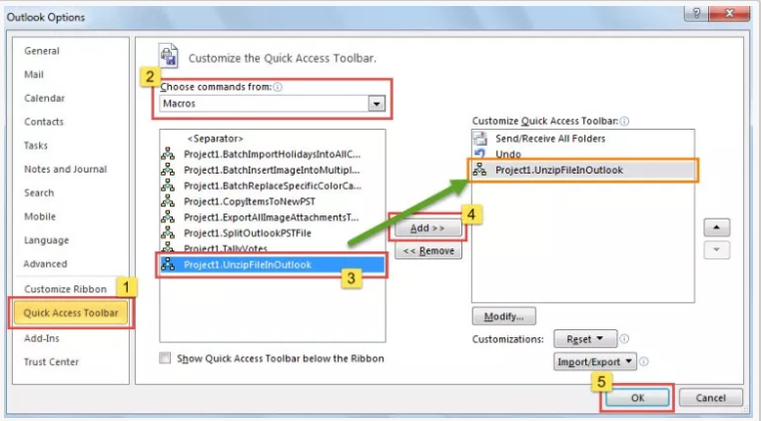

6] click on Modify Button and add Name for macro (you can add any name from your end )

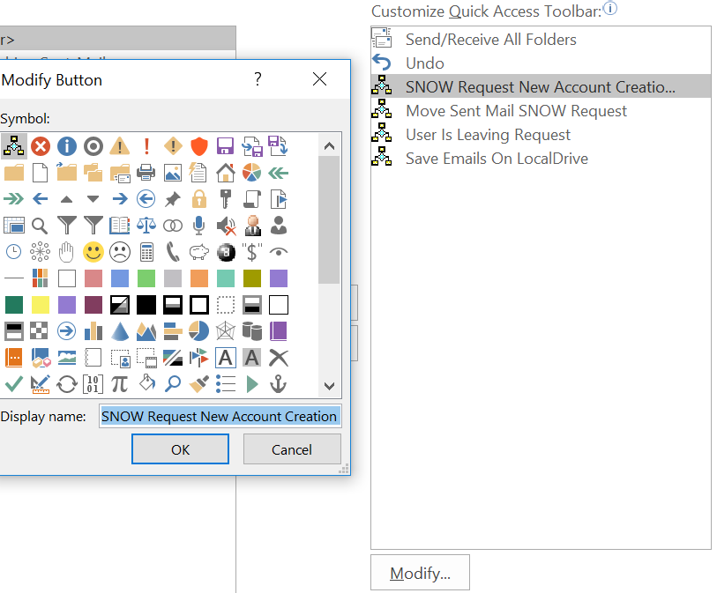

16] Finally, click “OK”.

17] **Save your file as a macro-enabled format**

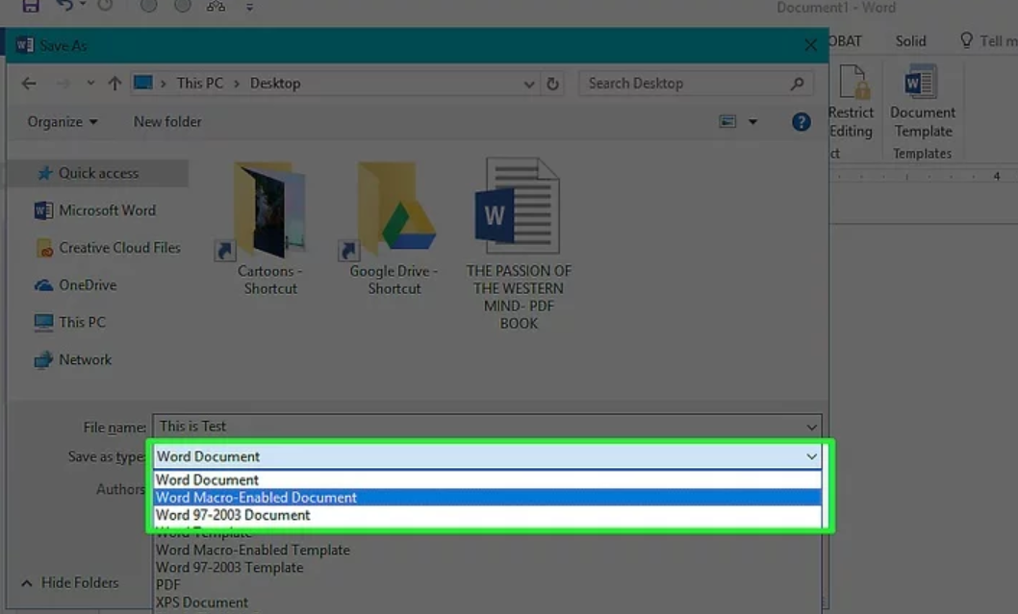

 Press either Ctrl+S (Windows) or ⌘ Command+S (Mac), then enter a file name, click the "Save as type" (Windows) or "Format" (Mac) drop-down box, and click the **Macro-Enabled** option in the resulting drop-down menu. You can then click **Save** to save the file with the macro enabled.

18] after that close that word file template

19] open macro file which we have saved

21] Do process of Mailing For Fill Data from excel to macro template

**22] to run this macro, you can simply click the macro button in Quick Access Toolbar.**



**After Run Macro do below things:**

1] you will get select Input Excel Files message box click on OK

2] after that you will get file selection option as select Input Excel Files

3] then select input excel file

4] then you will get message “LastRow of Excel : *” click on OK

5] then you will get message Select Folder For Save PDF Files click on ok

7] after that folder path selection option comes then select folder to save pdf file

8] after that you will get popup to save udated excel file with link

9] give any name and save it

10] finally you will get message “Word Records Converted To PDF successfully”

11] click on OK

12] after that you can compare word data with PDF Data

13] finally close macro template without saving It.